Pizza and the Patriarchy:
An Angry Italian’s relationship with food
One: Have you even read Eat, Pray, Love?
Dolce far niente translates to "the sweetness of doing nothing," this concept, this way of living is why Italians are so very connected to their food, friends, and family. They know how to step out of the hurried mess that is now thought to be "living." We do not hurry through meals or try to "recreate" ourselves in the evenings or on weekends as Wendell Berry discusses in his article The Pleasures of Eating. In Italy, store owners close up during the day for pausa pranzo, meaning lunch time, usually between 12:30 pm and 3:30 pm. During this time shop owners and workers head home for lunch with their families. This was once practiced by all businesses, but now in major tourist cities and malls it would be impossible, or if anything unprofitable. It is still practiced in many small towns, including Rivalta di Torino where my Nonna lives. (Nonna is Italian for Grandma, and Rivalta is a commune in the province of Turin, Italy.) If only the U.S. practiced these acts of unhurried enjoyment and relaxation, then maybe Americans could actually enjoy their food, escape obliviousness, and repress the ignorance encouraged by the food industry. Food can connect people and families if they only slowed down to enjoy it. The passive American consumer does not think about what he/she eats and does not take the time to enjoy their food. I use the inclusive “we” when discussing the Italian experience of eating, but in reality, America has tainted these traditions; I have become the passive American consumer.
When I was about five years old I developed a habit of picky eating that has followed partly into adulthood, but I can argue now that I at least try new foods instead of initially rejecting them based on appearance, and in this way have found many new favorite foods. This was a time before I became a passive consumer, a time when my mother’s cooking was central in my life, and I was only passive about learning to cook. I didn’t have to worry about where my food came from because one should be able to trust that their parents are making the best decisions when it comes to health and consumption. In reference to Relish by Lucy Knisley, chapter 6 “the craver” has resonated with me because it reminds me of my relationship with my own mother. Knisley’s mother is an amazing cook and so is mine; I would argue that my mother is the best, but I believe most people would argue the same about their own mothers.
Whenever I visit my mom I always request certain dishes because I crave the familiar scents and tastes of her food. Knisley mentions that she is the opposite of a picky eater, and this is where we differ. I was, and sometimes still display the signs of, a picky eater: turning away from certain foods, making faces, basically the whole routine of a picky eater. One dish that stands out in my childhood memories is Minestrone. You must be wondering why I’m bringing up Minestrone, well that's because it was one of the only dishes made from mostly vegetables that I would eat knowingly. I like to think it was because of the rich color the thick soup would turn out to be, but looking back now, I realize that I loved grinding the vegetables with my mom. This was a time before electric food processors, or maybe before I even knew what anything electric besides the magic picture box, which I know now as the TV, was. We had a red bowl that had a blade at the bottom of a metal plate with rows and rows of tiny holes. Attached was a crank that you had to turn over and over until all your veggies and potatoes were mush, and this act of pureeing was the only form of cooking that I actually wanted to take part in. My mother claims that nowadays I cannot cook because I didn’t actively watch her prepare meals; she blames technology for most my ignorance with food and life in general. I agree.
While reading the chapter 6, I also noticed that Knisley mentioned her mother meeting Julia Child, the cook famous for her love of French cuisine. It reminded me of the day my mother and I met the professional chef, Giada De Laurentiis, who hosts her own show on the Food Network, the same show we would watch together when I was younger. You would think that with all the cooking shows we watched together that I would have picked up a few skills, but this is not the case. My mother and I loved watching the various cooking shows on TV, but Giada’s show was one of our favorites. When we met Giada at her book signing event my mother was more excited than I was, and I remember that they spoke in Italian; her smile was radiant and she was very kind. It was an interesting experience that I was too young, and too ignorant, to appreciate until now. I grew up with so many resources and so many chances to learn, but I didn’t take advantage like I should have. There were so many teachers: my Mamma, Giada, and even my mom’s brother, my Zio (uncle) Carmine, a professional chef who trained for a number of years in Italy and England as well. Holidays would have been the perfect chance for me to observe and learn from these great people in my life. Christmas was a major holiday during my childhood where my family would share amazing dishes prepared mostly by my uncle and mother.
Two: We fight for seconds; Italian’s and their food
Christmas Eve is known as la Vigilia di Natale and it’s the most memorable of all because we only eat fish for dinner. La festa dei sette pesci, the feast of seven fishes, has some sort of Catholic affiliation; if I remember correctly it is celebrated as a commemoration of the wait, The Vigil, for the midnight birth of Jesus. Why seven fishes? Honestly, I have no clue. Some say it represents the number of Sacraments in the Roman Catholic Church. Others say that seven is lucky, the number which represents perfection. All I know for sure about the holiday tradition is that the food is tasty, and that’s all I really care about. The most memorable dish from the many Christmas Eve dinners we had would have to be the smoked salmon served with cold hard boiled eggs, the white and yellow separated, and chopped into little tiny cubes. It’s the most memorable to me because my cousin Stefano and I would fight over the two bowls which held the chopped egg whites and yolks. It doesn’t take much to prepare; you can buy a pack of smoked salmon at the store, and all you have to do is dice a few onions and hard boil some eggs and you’ve got an appetizer the whole family will fight over. It’s not a very special dish, but it will always be memorable to me because of our struggling over the bowls. Food brings my family together whether we are preparing it together or fighting over the scraps.
My family has a lot of experience in the restaurant business. I basically grew up in my uncle’s old restaurant, Luigino's, which sadly closed down in 2007, but now has a new restaurant in Virginia called Osteria Marzano. It has definitely influenced my attitude toward the service industry in many ways. I appreciate the hard work that goes into serving people, but I also fear ending up working in a restaurant for the rest of my life like my parents. There is nothing wrong with working in a restaurant, the restaurant industry employs over 10 million people in the U.S, and for that I’m grateful. My mom and dad have always worked for other people, whether it is my uncle or another employer, but I always try to encourage them to do something for themselves. I want to see my parents succeed beyond restaurant work because I am afraid of my own future. It might be too late for them to pursue other dreams, but what I do know is that my parents are very smart people because it takes a lot of knowledge and patience to work in a restaurant. My father is one of the smartest people I know. Ask him anything about every wine, and he will list you where it is from, and what it is made with. I admire my father a lot, but I do not want to be him. I love my parents, and I appreciate everything they have sacrificed for me, but I just can’t see myself doing the same things that they do.
My cousin Stefano is now in the process of becoming a chef just like his father. We always knew he had a gift, and a large appetite, so it’s a good thing he has access to so much food now. Then again that could be a bad thing. I once watched him eat plate after plate of sushi from one of those rotating sushi bars; it was frightening to say the least. One of my earliest memories of Stefano is watching him prepare a steak for breakfast when he was eleven and I was ten years old. It’s a memory that stuck in my brain, one that told me he had a talent I might never possess. As cousins of a similar age there tends to be a lot of jealousy here and there, I admit mostly on my end, but it always seemed like Stefano got everything when were younger. Sometimes it still seems that way, and I definitely still get jealous. Currently, I envy his career path. Not because I want to be a chef, but just knowing what he wants to do and that he loves it so much, that’s what I’m jealous of. It’s not the same as my anger over shared birthdays. We happen to be one year and one day apart. If I was born two hours later then we would share a birthday, but knowing my selfish nature even as a mere fetus, I had to have my own day. I was born on August 18th, 1995. Stefano was born on August 19th, 1994. He is my only blood-related cousin that lives in the U.S., but I cannot exclude my wonderful older cousin Elena, his half-sister, and amazing younger cousin Gianluca, who was adopted from Guatemala. I love them all dearly, including my twenty-one first cousins in Italy.
Three: Don’t eat like that!
When I was eleven, and Gianluca and Stefano were seven and twelve, our parents shipped us off to Italy for the summer. The experience of flying alone at that age was overwhelming for only one of us: Stefano, who cried and cried when we were on our connecting flight from Germany to Turin. A flight attendant gave him chocolates to help calm him, and it worked. Food can always provide comfort, even 40,000ft in the sky, and crying pre-teenage boys are always entertaining to watch.
My clearest memories of those three months in Italy all have to do with food. My Nonna is an amazing cook, and I loved eating everything she made for us, everything that my picky nature allowed of course. On the other hand, my Nonno is a tough guy. Stefano was obviously his favorite, and I always felt left out. He is truly a patriarchal man and carries the same values that have been passed down for centuries. His only son, Stefano’s father, was his favorite. How could I have been surprised to receive the same cold shoulder my mother and her two sisters had received? I suppose I just didn’t understand the concept of the patriarchy or being the least favorite grandchild in my Nonno’s eyes.
One day when we were having lunch altogether, I discovered I had an annoying habit while eating. Well, it was more blatantly pointed out by my Nonno than discovered on my own. We were enjoying pasta with fresh tomato sauce, salad, and bread. You can’t sit at an Italian table without bread being present; it’s our staple food. The salad was the dish that paved the way for my memory and my embarrassment. You see, my Nonno makes his own Accetto di vino or wine vinaigrette, and I love red wine vinegar to the point of wanting to drink it, which I have done in the past and sometimes still do. The salad we had that day was drenched in the stuff, and I was having seconds and thirds, up until I realized everyone at the table was staring at me. What had I done? My Nonno looked at me with a disgusted face and said, “Ma perché mangi in questo modo?” Which translates to “Why do you eat like that?” I had no idea what he meant, but at that point my Nonna defended me, telling him to leave me alone because I was enjoying my food. It turns out that when I was younger I tended to make a low moaning sound while eating. I had no idea until my Nonno pointed it out so rudely. I really knew the pleasures of eating when I was a child, but now I always have to monitor myself. I have to make sure I don’t make “strange” sounds, and in a way it distracts me from enjoying my food. Men like my Nonno are the reasons women struggle to enjoy their lives and their food. If it’s not strange sounds, it’s overeating, or not eating enough. There will always be something to be pointed out and looked down upon.
Four: I will never cook for a man
Layer upon layer of pasta, tomato, béchamel sauce, mozzarella, and Parmigiano; lasagna is the dish I call home. Whenever I visit my mother, the first thing I ask her to make for me is lasagna, or it’s more chaotic form: lasagna pasticciata which translates to “messy pasta.” I have yet to come across lasagna better than hers. It has come to be my comfort food because after a long period of absence from my childhood home, I know I’ve truly arrived once I’ve had a few serving of my mother’s lasagna.
The day I decided to attempt cooking her lasagna on my own, it did not produce any feelings of comfort or remind me of home. No lasagna was made. All it comes down to is this: Men are unreliable. I refuse to ever become a housewife. Especially if being a wife includes domestic work such as cooking. I am certainly not patient enough, and I am not a skilled cook or a slave to the male gender. I especially do not like waiting for men. It was a Saturday, another work day as per usual, but I got off at four. It was the day I planned to attempt to cook my mom's lasagna, and it was all for a guy. A cute, stupid, and clueless guy, and I was so excited despite everything I had due that Monday. I was willing to push all my responsibilities to the side for a few hours to cook with this boy, but in the end, he canceled. I somewhat knew he would, and yet I still planned. That was my first mistake.
I woke up early that morning and made a tomato sauce in preparation for the lasagna the guy had requested I make for him. I had the idea that we could prepare it together. I was stupid enough to plan and shop for every ingredient with a pleasant smile plastered on my stupid, smug face. Right up until the moment I finally admitted to myself that he wasn’t coming, and then my lips formed into an angry line. I knew. I knew and yet I planned. I purchased. I performed. This was not me. Not the real me.
I don't cook! And all for some guy? Was I going to cook? Ha!! I barely cook for myself, and a man should be cooking for me, not the other way around! Do you know what it’s like having a crush? Do you know what it's like to plan something so elaborately and then the person you were trying to impress doesn't even show up? Well, it all sucks. Food is supposed to bring people together, and all it managed to do was shatter my heart. Or maybe that was just the boy. Maybe food was my only comfort to fall back on in the end.
The next day, I made the lasagna on my own. I didn’t need to make it for anyone, and I didn’t want to make it for anyone either. I made it for myself to prove that I could cook something so elaborate on my own. Although it lacked some salt, the result was surprisingly good. It had the same consistency as my mom’s lasagna, and I felt proud to have accomplished something. I learned something important that day: never share your comfort food with those who won’t appreciate it, and never cook for any guys. Also, calling one’s mother on FaceTime every five minutes to ask questions still counts as cooking on your own.
Five: I am what I eat
"I'm Italian"
"Oh you're Italian, I speak Italian!"
"Really?"
"Yeah! Pizza, spaghetti, bippity boppity boopity!"
"I hate you."
I am Italian and, therefore, I am pizza, spaghetti, lasagna, etc. I accept this role. Call me Spaghetti, Tomato lover; even morph my last name with Ramen noodles which aren’t even Italian, but just Italian enough. Even my mom’s last name, Marzano, is the name of a brand of canned tomatoes. I cannot escape Italian food, and maybe I don’t want to. I am my comfort foods.
♦♦♦
Recipe for Mamma’s Lasagna:
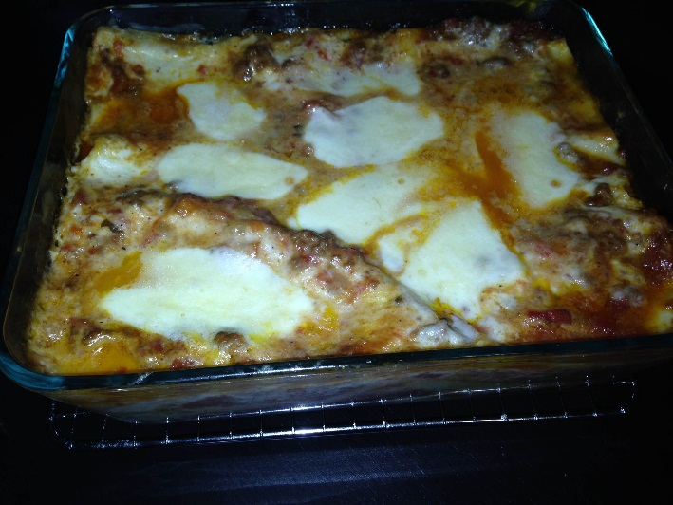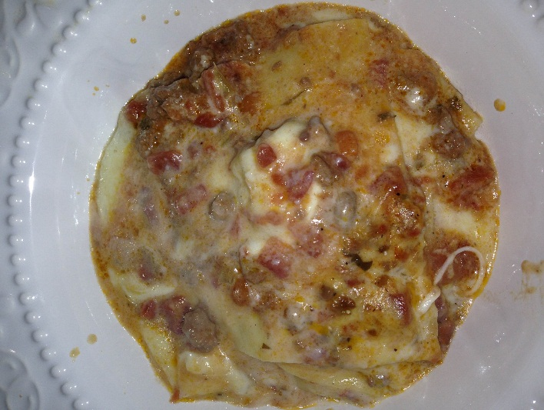
Recipe for Lasagna Pasticciata: without measurements because my mother doesn’t measure ingredients when cooking such a familiar dish.
• First of all, you make tomato sauce, use a few cans of tomatoes, preferably San Marzano tomatoes.
• Olive oil, garlic, onion salt, and pepper to taste, sautéed garlic and onion in the olive oil add tomato sauce.
• Salt and pepper to taste! Cook 30 to 40 minutes.
• Then make béchamel sauce: flour, butter, salt and pepper to taste, nutmeg!
• Melt butter in a saucepan over medium heat, add sifted flour mixed together, add milk, and keep mixing with a whisk so as not to form lumps! Add salt and pepper and nutmeg!
• Whisk until desired consistency. Then put a big pot of water to boil then add salt and a little oil, cook the pasta, not too much: leave it al dente.
• Drain and put the pasta in cold water to stop it from cooking any further. Put the pasta to dry on a kitchen towel!
• Cut mozzarella in cubes, grates the Parmigiano. Now you ready to assemble the lasagna! Put some tomato sauce on a baking dish, layer some pasta, tomato sauce, mozzarella and Parmigiano.
• Keep going until you finish all ingredients. Baked at 350 degrees for 35-40 min!

♦Pictures♦
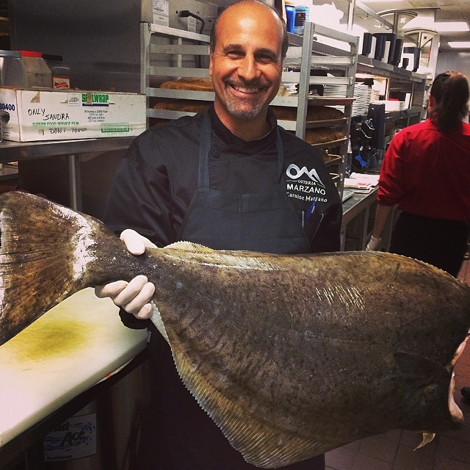
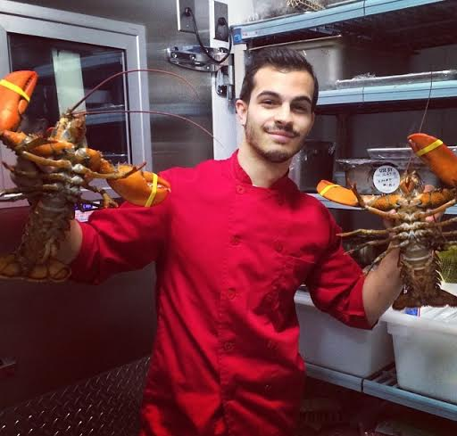
My Zio Carmine:
Steo:
Stefano, Elena, and Me:
Mamma:
My Cousin Stefano:

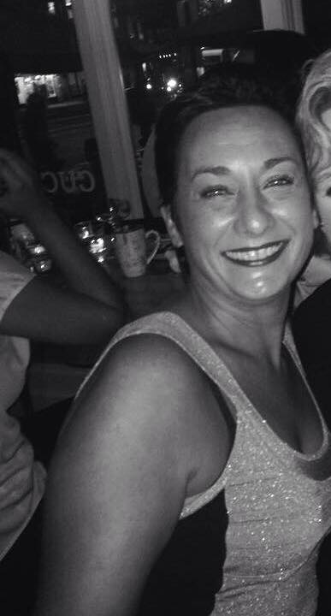
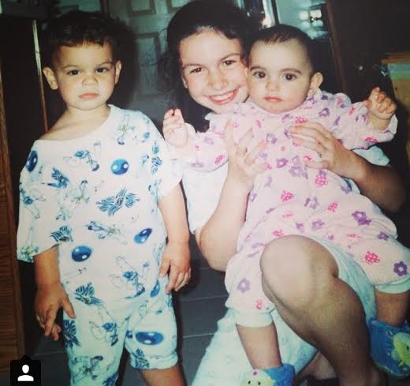
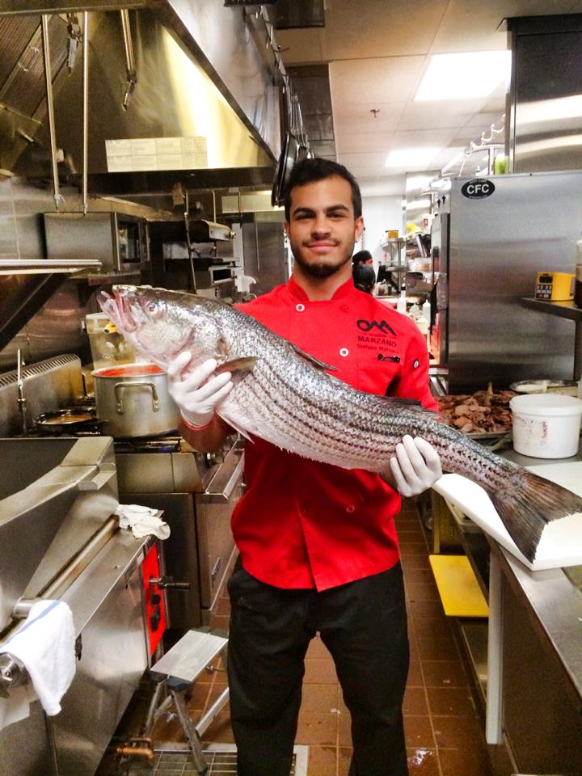

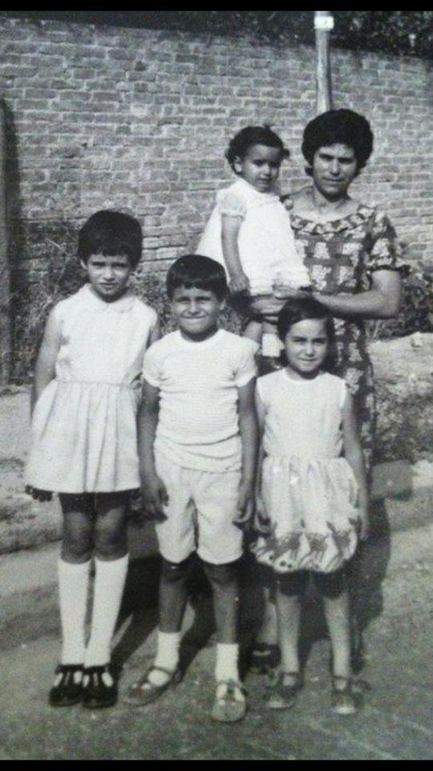
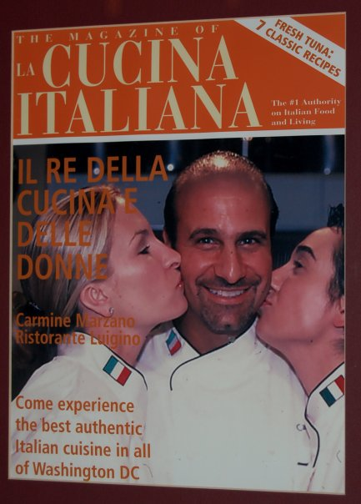
Zia Deborah, Zio Carmine,
Nonna, Zia Tina, Zio Carmine, Mamma, and Zia Birba and Mamma:

